CHAPTER 5
APPLYING NEWTON’S LAWS
Discussion Questions
Q5.1 The force diagram for the man plus seat is given in Fig. DQ5.1a. 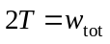and therefore 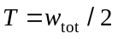. The tension in the rope is 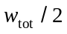, where 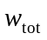 is the weight of the man plus the weight of the seat. The force diagram for the man is given in Fig. DQ5.1b. 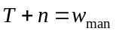and . If the weight of the seat can be neglected compared to the weight of the man, then 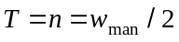. In this case the tension in the rope and the force of the seat on the man are each half the weight of the man. If the weight of the seat equals the weight of the man, 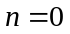 and 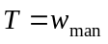; the seat exerts no force on the man and the tension in the rope equals the weight of the man. If the seat weighs more than the man and the man isn’t strapped in, then 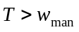 and 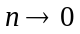. The man accelerates upward and the seat accelerates downward.

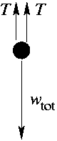
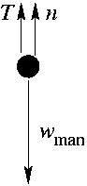
Figure DQ5.1a Figure DQ5.1b

Q5.2 (1) If a book sits at rest on a horizontal tabletop the only vertical forces on the book are the upward normal force and the downward weight, and these forces are equal in magnitude. (2) If a crate sits at rest on a ramp that is inclined at an angle above the horizontal, the normal force is . (3) If a crate sits on a horizontal surface and you push on the book with force that is at an angle below the horizontal, then 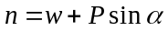.

Q5.3 Only the vertical components of the tension at the ends of the rope hold it up; 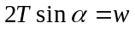, where is the angle of the rope below the horizontal at each support. 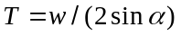. As 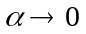, 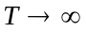.

Q5.4 The force diagram for the car is given in Fig. DQ5.4. is the weight of the car. This force is vertical. It has a component perpendicular to the incline and component 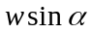 parallel to the incline. 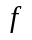 is the air resistance force exerted by the air on the car. It is directed opposite to the velocity of the car so is parallel to the ground and directed down the hill. The force the ground exerts on the car has two components. The component perpendicular to the ground is the normal force . The component parallel to the ground is 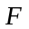; the ground pushes on the tires because the tires push on the ground. It is the force that pushes the car up the hill; the ground pushes the car up the hill.

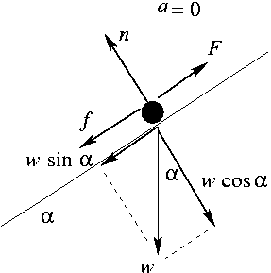

Figure DQ5.4

Q5.5 Use Newton’s 2nd law. Apply a known force to the astronaut (for example with a rope attached to a spring balance) and measure his acceleration.

Q5.6 Push parallel to the ramp: The force diagram for the box is given in Fig. DQ5.6a. 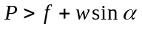.
Push horizontally: The force diagram for the box is given in Fig. DQ5.6b. 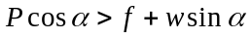.
When you push horizontally only the component of your push parallel to the ramp is effective at moving the box up the ramp. Not only that, but the other component of your push, the component perpendicular to the ramp, increases the normal force which in turn increases the friction force that opposes the motion.

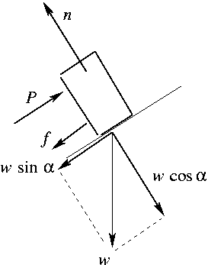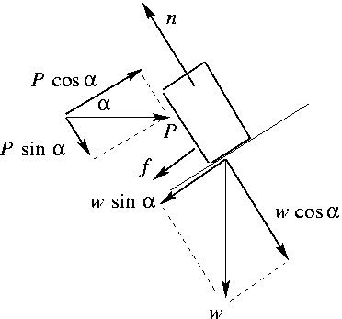

Figure DQ5.6a Figure DQ5.6b

Q5.7 When she releases the briefcase, the only force on it is gravity and in the inertial frame of the earth it accelerates downward with 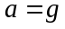. If the briefcase isn’t moving relative to the elevator, the elevator must also be accelerating downward with acceleration .

Q5.8 There is a component of the weight of the block that is directed down the incline. To start the block moving down the incline, the force you apply must satisfy 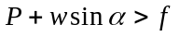 and 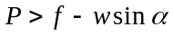. is in the direction of your push and adds to it. To start the block moving up the incline, must satisfy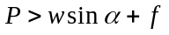. is opposite to your push and subtracts from it. To push the block sideways, it must be that 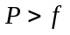. It is easiest to get it moving down the incline and hardest to get it moving up the incline.

Q5.9 Let the crate have mass and let the ramp be inclined at an angle above the horizontal. Since the ramp is stationary, the kinetic friction force is always directed opposite to the motion of the crate. When the crate is moving up the ramp, the kinetic friction force 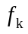 that the ramp exerts on the crate is directed down the incline and the net force on the crate is 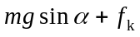, directed down the incline. The acceleration of the crate is 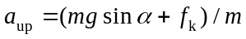. When the crate is moving down the ramp, the kinetic friction force is directed up the incline and the net force on the crate is 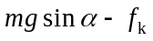, directed down the incline. The acceleration of the crate is 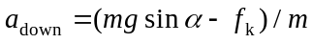. This shows that 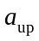 is larger in magnitude than 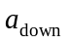. The crate slows down at a greater rate when it is going up the ramp than the rate at which it speeds up when it is coming down the ramp. The result is that the speed of the crate when it returns to the bottom of the ramp is less than the speed it had initially when it started to slide up the ramp. When the crate is going up the component of the gravity force parallel to the ramp and the kinetic friction force are in the same direction and when the crate is coming down they are in opposite directions. The net force on the crate, and hence its acceleration, is greater while it is sliding up than while it is sliding down.

Q5.10 In either case the component of your force that is horizontal is 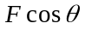. But if you pull at an angle above the horizontal your force has an upward component 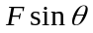 and the normal force is 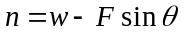. If you push at an angle below the horizontal your force has an downward component and 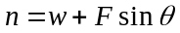. If you pull above the horizontal the normal force is reduced; if you push below the horizontal the normal force is increased. Increasing the normal force increases the friction force that opposes the motion. You exert a smaller force when you pull at an angle above the horizontal.

Q5.11 The friction force is always parallel to the surface that applies it. (a) Can’t do. A horizontal friction force in toward the center of the curve is required in order for the car to move in an arc of a circle. (b) Can do. You jump into the air by pushing downward on the floor. (c) Can’t do. To start walking requires a horizontal acceleration, which requires a horizontal force. (d) Can do, by pushing upward on the ladder with your feet. But as in (b) it is more difficult without friction, to avoid slipping. (e) Can’t do. To change the direction of the car’s velocity requires a horizontal friction force exerted by the highway surface on your tires.

Q5.12 The coefficient of kinetic friction is much less than the coefficient of static friction. The maximum static friction force is much larger than the kinetic friction force; once slipping starts the friction force is greatly reduced.

Q5.13 The acceleration of the elevator affects the normal force, and the kinetic friction force that you must push against is proportional to the normal force. When the elevator is accelerating upward, the crate is also accelerating upward and the upward normal force is greater than its weight. When the elevator and crate are accelerating downward, the normal force is less than the weight and when the elevator is traveling at constant speed the normal force equals the weight. The force you must apply is greater when the elevator is accelerating upward and least when it is accelerating downward.

Q5.14 (a) Place a glass of water on a piece of paper. Pull horizontally on the paper so that it accelerates. The friction force that the paper exerts on the glass of water accelerates the glass, causing it to move horizontally along with the paper. (b) Drop a box onto a rapidly moving horizontal conveyor belt. The friction force the belt exerts on the box causes the box to start to move horizontally in the direction the belt is moving. Until the box attains the same speed as the belt it is slipping relative to the belt and the friction is kinetic.

Q5.15 The speed doesn’t change because there is no component of net force in the direction of the particle’s velocity. The net force and hence the acceleration are perpendicular to the velocity, and this produces a change in the direction of the velocity but not in its magnitude.

Q5.16 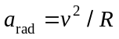. At 80 km/h the inward horizontal component of the normal force equals 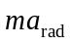. At 20 km/h, 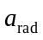 is significantly less and the inward component of is much greater than . The horizontal component of pushes the car out of its circular path; it slides down the banked roadway and off the road.

Q5.17 The acceleration of the ball is horizontal so in the vertical direction the net force must be zero. The tension in the string must have an upward component to balance the downward gravity force on the ball. Therefore, the string cannot be truly horizontal, it must slope downward below the horizontal as viewed from the center of the circle toward the ball. See Fig. DQ5.17.

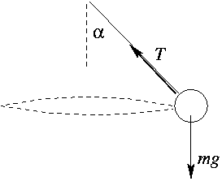

Figure DQ 5.17

Q5.18 There is no such thing as a separate centrifugal force. This is just a name given to the net force, the vector sum of the actual forces, for circular motion.

Q5.19 No. The velocity of the stopper is tangential and the stopper will move in the tangential direction if the horizontal force on it is removed.

Q5.20 At the bottom of the circle, 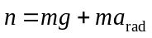. At the bottom of the circle is largest and can be large. is reduced by increasing .

Q5.21 With the air removed the ball is in free-fall and has downward displacement 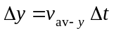 in each successive time interval between flashes. Since 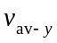 for each time interval increases as the ball speeds up, the displacement of the ball between successive flashes increases. With air resistance the acceleration decreases as the ball falls and gains speed and its displacement between flashes increases less rapidly. If the ball reaches terminal speed, then the distance it travels between flashes becomes constant.

Q5.22 (a) In the absence of air resistance 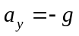 throughout the motion. So, constant acceleration equations apply: 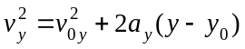. When 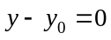, 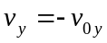; the speed when it returns is 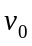. (b) With air resistance it doesn’t go as high and speeds up less rapidly on the way back down, so has speed less than when it returns.

Q5.23 On the way up, the air resistance force is downward and the acceleration is greater than g. On the way down, the air resistance force is upward and the acceleration is less than g. The distance up is the same as the distance down, so it takes longer to come down than to go up.

Q5.24 If air resistance is negligible, each ball has the same downward acceleration and strikes the ground at the same time. With air resistance , 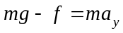. 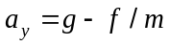 and 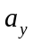 is less than . The air resistance force depends on speed and on size and shape of the object but not on the object’s mass. At a given speed will be the same for both balls but the effect on 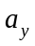will be less for the more massive one, the one filled with water. The one filled with water will strike the ground first.

Q5.25 The net downward force on the ball is its weight mg, which is constant as the ball falls, minus the upward force due to air resistance. The upward air resistance force increases as the speed of the ball increases as it falls. So, the net downward force decreases and the magnitude of the downward acceleration of the ball decreases as the ball falls. The acceleration steadily decreases, until it becomes zero at the terminal velocity. Graph (d) matches this behavior.

Q5.26 “Dropped from rest” means the initial speed of the ball is zero. The speed of the ball increases until the ball reaches the terminal speed, at which point the speed stays constant. Graph (a) matches this behavior.

Q5.27 There is a horizontal component of air resistance that causes the horizontal component of the velocity to decrease. The ball is traveling with smaller horizontal component of velocity on the way down so travels a shorter horizontal distance.

Q5.28 The only horizontal force on the ball is the horizontal component of the air resistance force. This force is opposite to the horizontal component of the ball’s velocity and causes the horizontal component of velocity to decrease. This continues until the horizontal component of velocity is zero and then the horizontal component of air resistance is also zero. The ball reaches its horizontal terminal velocity, which is zero. After the horizontal component of velocity has become zero, the ball moves vertically downward.

